Game Design Document

Fill up the following document

1. Write the title of your project.

Pop the balloon

1. What is the goal of the game?

Pop the balloon using arrow

1. Write a brief story of your game.

Pop the balloon using arrow and avoid hittning stones

1. Which are the playing characters of this game?

* Playing characters are the ones who respond to the user based on the input from the user.
* Cars, monkeys, dinos, wizards, etc., are the playing characters in the game.

|  |  |  |
| --- | --- | --- |
| Number | Character Name | What can this character do? |
| 1 | Bow | Shoot arrows |
| 2 | arrow | Pop the balloon |
| 3 |  |  |
| 4 |  |  |
| 5 |  |  |
| 6 |  |  |
| 7 |  |  |
| 8 |  |  |

1. Which are the Non-Playing Characters of this game?

* Non-Playing characters are the ones that don't have an action or behavior when the user interacts with the game.
* Hurdles, stones, bananas, coins, etc., are non-playing characters in the game.

|  |  |  |
| --- | --- | --- |
| Number | Character Name | What can this character do? |
| 1 | balloon | Increase score if poped by arrows |
| 2 | stone | Stop arrows from poping balloons |
| 3 |  |  |
| 4 |  |  |
| 5 |  |  |
| 6 |  |  |
| 7 |  |  |
| 8 |  |  |

Draw your imagination of this game. What does this game look like?

* Draw the game either on your computer or on paper.
* Add images of the game scenes to show each of the playing and non-playing characters at least once.

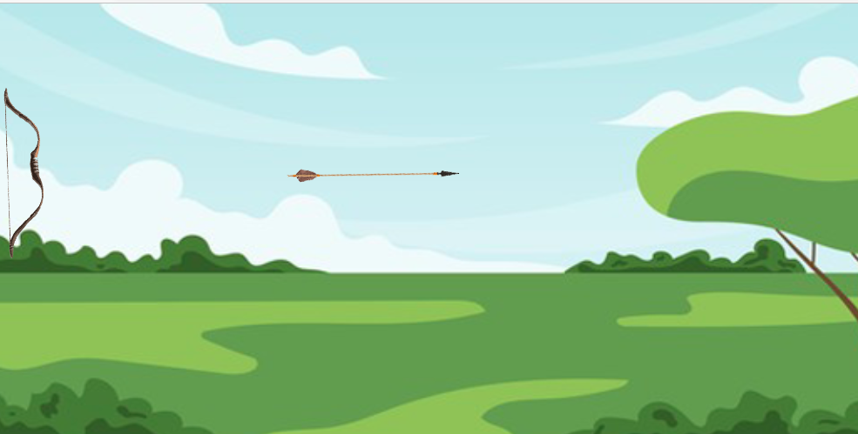

How do you plan to make your game engaging?

By adding scores, players try to increase their score by getting better and better each time.